First "Digital Substation" 110 kV, using the IEC 61850 (-8-1 and-9-2LE) for measurement, protection and control switching devices in Russia.

21, rue d’Artois, F-75008 PARIS B3_ 110_2014 CIGRE 2014
http : //www.cigre.org

Y.I. MORZHIN*, S.G. POPOV, Y.V. KORZHETSKIY, M.D. ILIN
JSC “R & D FGC UES”
Russia

SUMMARY

The article discusses components of the development of technology, which in Russia is called "Digital Substation". This technology is based on IEC 61850. The basic components of the technology are construction a reliable communication network for the IED terminals (in terms of standard "process bus" and " station bus"), as well as field testing of equipment from different manufacturers on the possibility of joint work (check requirements of the standard - interoperability) for use in operational practices.
To solve these tasks created a testing- field Digital Substation in "R&D FGC UES", based on the existing experimental AC substation 110/10 kV, which is powered by a 110 kV electric networks of the regional network of JSC "Moscow United Electric Grid Company."
Testing field consists of 2 parts - the substation and laboratory related unified communications environment.
The structure of the substation: control center of substation with protection terminals and measurement IED, communication networks, equipment of time synchronization , optical measuring current and voltage transformers, converters analog and digital signals (SAMU) outdoor performance on outdoor switchgear 110 kV substation.
The laboratory of part testing ground is a hardware and software of complex Real Time Digital Simulator (RTDS) and other hardware and software test systems (OMICRON CMC 256 plus, RETOM-61850).
Testing ground is necessary for the decision of tasks of development of an optimal architecture of the communication environment for the build process bus and "bus station" for substations of various voltage classes, accordance with the requirements of the standard IEC 61850 and study its characteristics.
Research performed at the testing ground directed on development of technical documentation in the form of technical requirements for primary and secondary equipment which can be applied to new technology.
A testing-ground Digital substation is intended for familiarization of employees of power grid companies, design and commissioning personnel with new technology.
At the testing ground is conducted experimental operation of equipment designed in accordance with the recommendations of the IEC 61850 standard, different vendors.
Employees of the testing ground Digital substation, together with other industry electricity organizations, develop the programs for training courses, recommendations for the design, commissioning and operation of new equipment.
JSC «FGC UES» assigns JSC "R&D FGC UES" coordinating role in developing a technology of Digital substation and implementation of the operational practices of the grid companies of Russia.

KEYWORDS

Electrical substation- IEC 61850, IED terminal- “Digital substation” technology- Testing field, RTDS- Tests

Substation 110 kV JSC “R & D FGC UES” provides power for experimental testing equipment for high-temperature superconducting cable line (HTS), devices and systems for reactive power compensation, inserts of direct current and power electronics. Measuring optical current and voltage transformers type NxVCT (Canada) and field current and voltage transducers (Merging Unit-MU, Russia) on the 110 kV and 10 kV sides was installed in 2010-11 in the open switchgear 110 kV. For the secondary equipment was designed communication environment, “process bus” (IEC 61850-9-2LE) and “bus station” (IEC 61850-8-1), implemented on the basis of digital switches RSG 2100 and RSG 2288 (RuggedCom Inc, Canada). Separation of the communication environment for "measuring" (256 samples per cycle) and "relay" (80 samples per cycle) circuits are implemented by VLAN configuration of the digital switches.
As a measuring device using the universal multifunctional intelligent electronic devices (IED).) DPM-121 (Modern Measurement Systems Inc., USA). They carry out the measurement of current values of current and voltage, active and reactive power and energy parameters of quality of electric power. Relay protection presented terminals differential protection of the power transformer RET-670 (ABB) and controller switch line REC-670 (ABB), the protection of «bar» SEL-421-SV (Schweitzer Engineering Laboratories, USA)) and backup management controller switch line SEL-421-SV. The latter manages a high-voltage switch with the help of digital streams in the form of a GOOSE messages. As a substation control systems applied SCADA-system КОТМИ-2010 (ДЕЦИМА, Russia), which is connected to the «bus station» with the above mentioned IED. The feature of the SCADA-system is to use the driver of the Protocol IEC 61850-8-1 (without the use of OPC-technology). Source the exact time is a satellite synchronization of GPS/GLONASS, the PTP Protocol IEEE 1588, make time to arrive at the server of precise time and on an Ethernet network packets with the time stamps are transferred IED-terminals, in addition to the substation is applied instrumental sync for sync packages Sampled Value (SV), transmitted by the Protocol of the IEC 61850 (-9.2LE).
Communications environment of substation connected with test-simulation system implemented on the basis of hardware and software Real Time Digital Simulator (RTDS Inc, Canada). All the above-mentioned equipment forms a testing field "DSS". Test-simulation system application allows to simulate disturbances (short circuits, power off the line) in a virtual external power supply, generate SV flows, GOOSE-and MMS-messages for estimating of the load capacity of digital communications equipment.

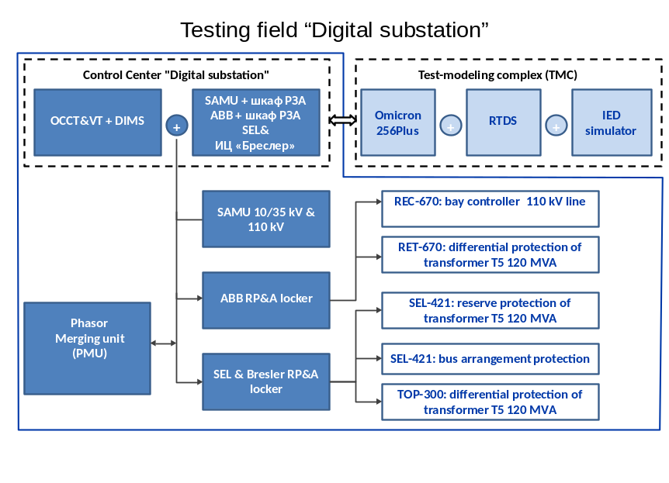

Fig. 1 Structural scheme of Testing field “DSS” of JSC R&D FGC UES

The main objectives to create testing field "DSS" are:
- Research of the statements of IEC 61850, for its practical application. Development of the concept of building hardware and software of "DSS." Research of communication environment architecture for "process bus" and "station bus", the search for optimal solutions in terms of segmentation and backup substation buses of different voltage class. Development of practical recommendations for the design of communication architecture of "DSS."
- Development of technical requirements for all types of equipment (primary, secondary, communications), based on the statements of the IEC 61850 standard, for use in the "DSS."
- Carrying out tests on the compatibility of equipment of different manufacturers to be applied on the "DSS" and the technical solutions offered by integrators.
- Development of educational materials for setting up and operation of equipment of "DSS."
- Conducting training of electric grid staff of operational, commissioning and project organizations technologies used by the "DSS."
- Implementation and development program of the technology "DSS" in electric power networks Russia.

“DSS” technology. Stages of developing and implementation.
Any technology is a set of components connected into a single business process.
New technology must have conceptual idea of its creating, on what it based and what purposes it achieves. Figure 1 conceptually represented the goal of DSS.
Means to achieve these goals are:
- Simplification and harmonization of all secondary circuits of substation, what should lead to cheaper operation and faster commissioning of facilities, it is implied by the introduction of more advanced electrical equipment on substation
- Migration to the “unattended” substations (ie maintenance of substation without constant watch on them of operational staff)
- Independence from the hardware vendor.

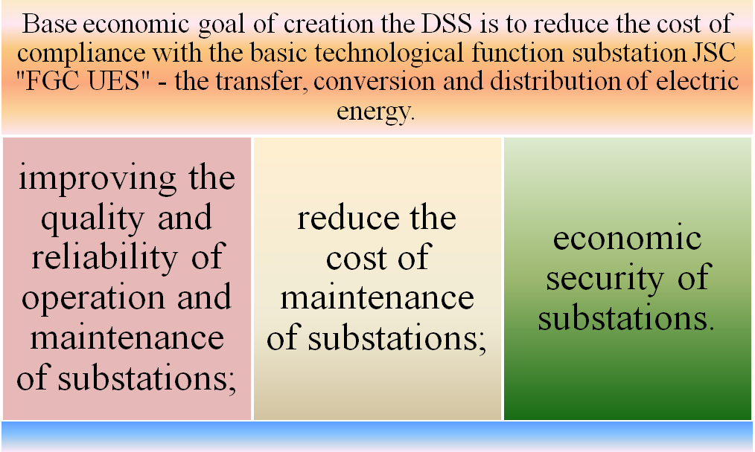

Fig. 2 Purposes of creating DSS.
For providing goals set at the creation of “DSS” you must understand that you need to solve quite a number of various tasks at certain stages. These tasks cover the area of economy, technology policy, conducting research and development activities, development of technical solutions, regulatory, technical and methodological support, training of personnel and industry development of new types of equipment. Development and introduction of new technologies requires a concentration of investments by the government and private companies to multi-year perspective. Justification of these investments should be based on the concept paper, covering the basic provisions of technology and stages of its creation, and in fact, the road map.
In the view of the authors, the steps for creating technology "DSS" shall be as follows:

Stage 1. Development of the concept [1, 2].
Figure 3 shows the structure of the concept of DSS.
Tasks of current concept:
- Identify the main path of development of modern automation systems UNEG substations to “digital” level, milestones and priorities for work areas:
- R&D
- Methodology of application of IEC 61850
- Development of technical documentation
- Development of design and creation CAD
- Certification and testing
- Test of software and hardware systems (SHS) and its components (testing field “DSS”)
- Training of personnel
- Pilot projects (development of requirements for “Pilot” tasks).
- Formulate the basic provisions of technical requirements for SHS of DSS as a whole and its individual components.
- Formulate a problem questions appearing in introduction of “DSS” technology.

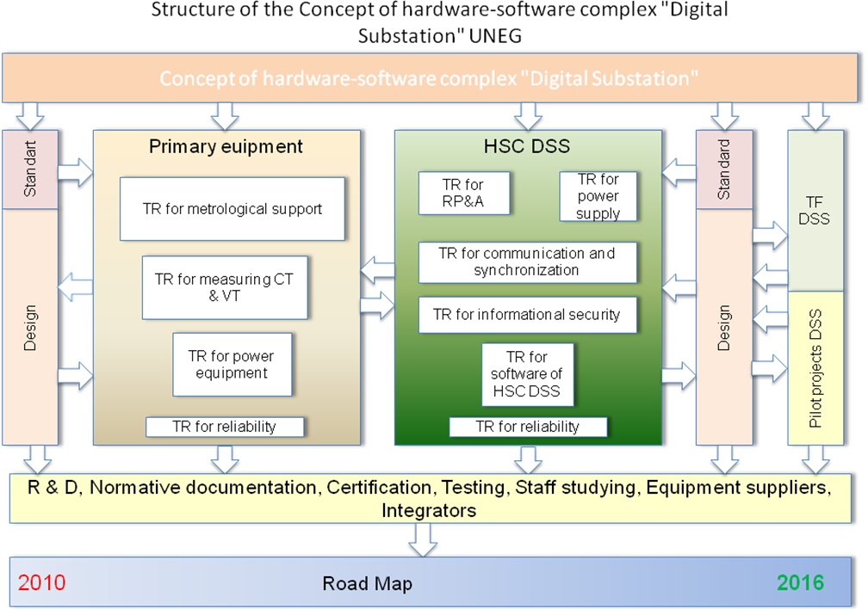

Fig. 3 Structure of the concept of DSS

Stage 2.
Development of technical requirements for primary and secondary equipment of DSS provides the interaction between equipment by digital information flows.
Development of requirements for metrological support of equipment of DSS.
Development of technical requirements for communication environment of DSS, taking into account the interaction with the system of universal time of substation.
Development of technical requirements to architecture SHS of DSS (level of technological process, the level of connections, the upper level of the SS and the interaction with the upper levels of network management - NCC, Dispatch Center of the System Operator).
Development of technical requirements for information technological systems of DSS.
Development of technical requirements for APCS of DSS (SCADA, technological ARM (s) subsystems APCS).

Stage 3.
Creating a testing field "DSS" (including current electrical equipment of DSS test-modeling and testing software and technical complexes). At this field equipment of secondary switching is testing to work together according to IEC 61850 (-8-1 and 9-2LE).

Stage 4.
Perform R & D for the production of prototypes of equipment, research on the development of technical solutions for application to the DSS.

Stage 5.
Conducting field tests equipment and technical solutions by developed methodology based on the provisions of Chapter 10 of the IEC 61850 standard.

Stage 6.
Development of technical documentation based on the methodology of application IEC 61850 standard required to create and opera DSS.
One of the urgent task is to develop technical documentation needed to create technology "Digital Substation".
Lack of complete and well-defined normative base creates barriers in the implementation of innovative technologies in the electricity sector. Analysis of the existing regulatory framework, allows you to define a list of the most important documents required for the design, implementation and operation of the DSP (complementary documents for the implementation of substation, currently in use).

Stage 7.
Certification and validation of primary equipment and SHS DSS.
Currently, the process of certification of equipment used in electrical UNEG quite a lengthy procedure, so for the "pilot" objects of DSS appropriate to apply the procedure - "declarative certification", which is carried out after the tests of the presented equipment to work together in accordance with IEC 61850.
Stage 8.
Training operating personnel to work at DSS.

Stage 9.
Development of requirements for tasks of “Pilot” projects.
At this stage of the technology "Digital Substation" its practical implementation on the "pilot" objects - UNEG substations only begins, so it's important to understand what result we obtain after implementation. One of the objectives of this stage - studying questions to create an optimum architecture "station bus" and "process bus" with regard to reservations for substations of different voltage class and functions. According to the results of the "pilot" implementation should be prepared standard solutions for architecture communication environment for various types of substations and voltage classes.

Stage 10.
Development of “pilot” projects.

Stage 11.
Implementation of "pilot" project at UNEG substations.

Stage 12.
Analysis and summary of the results of the "pilot" implementation. Correction technical solutions, technical documentation, testing methods and testing primary equipment of SHS DSS, design solutions.

Stage 13.
Development of DSS design methodology. Creating CAD, providing integration with terminal configuration description language (SCL-IEC 61850 -6).
Figure 4 shows the "road map" of development and implementation of technology "Digital Substation", which allows us to represent the volume and complexity of the present and future work.

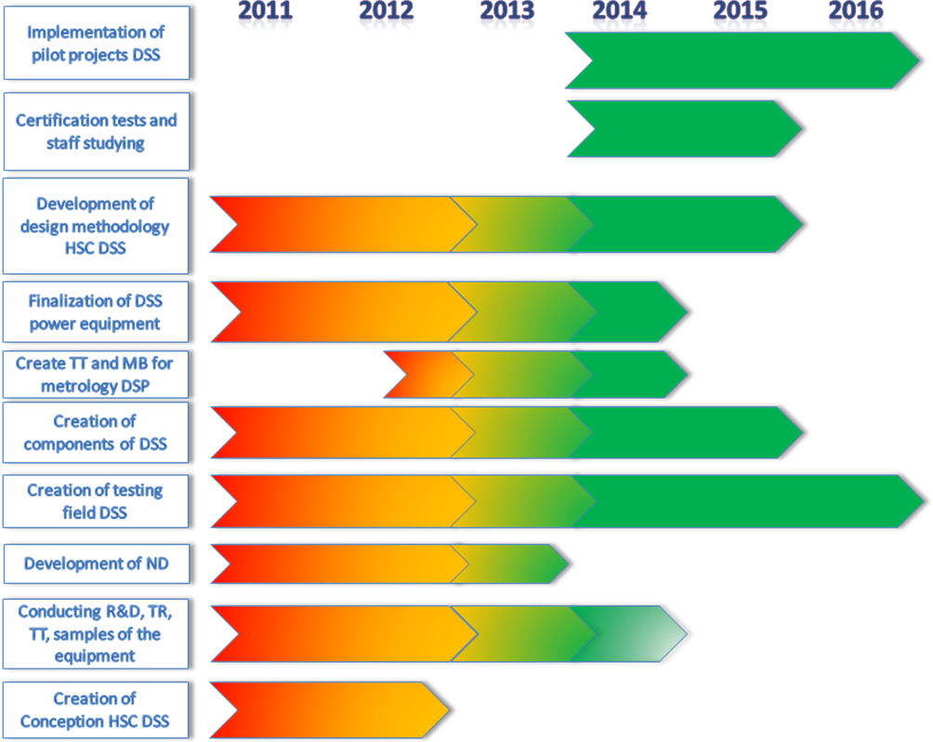

Fig. 4. Road map of development of technology DSS.
JSC "NTC UES FGC" together with partners are purposefully working to create technology" Digital Substation” since 2010. During this period the following works were carried out: the Concept , performed R & D in the field of prototypes of outdoor converters - analog signals into digital format flows in IEC 61850-9-2LE (SAMU), discrete signals (field converter high-voltage switch communication network receives GOOSE messages, and the coils off / on switch actuator issued 220 operating current from the switch actuator through the converter into the communications network transmitted position auxiliary contacts and diagnostic signals ), devices to control digital information flows in the format of the IEC 61850-9-2LE (80 and 256 samples per power frequency) - the communications traffic analysis and measurement of dynamic interaction characteristics of the communication network. The study on the optimal construction "process bus" and "station bus", the results of these studies will be discussed in the following sections of this report. In general, the formation of a testing field "Digital Substation" is completed: a common communications environment for IED-terminals (secondary switching device at the substation) and test-modeling complex of laboratory part. This is not a complete list of works carried out over the period. This work would not have been accomplished without the financial support of the customer - JSC "FGC UES" during this period, which once again proves the necessity for government support of R & D targeted at creating new knowledge-based technology to automate electrical substations.

Tests and research on the testing field "Digital Substation"
First results of researching technical solution for pilot substations of cluster “Elgaugol” on testing field “DSS” showed the ability of interoperation of equipment of different manufacturers created with IEC 61850 implementation – SEL, ABB, RC Bresler, merging units (analog and discrete) of Micronika, EDC Kontinuum, electricity meter of Landis&Gyr. The structural scheme of testing equipment connection is presented on figure 5.
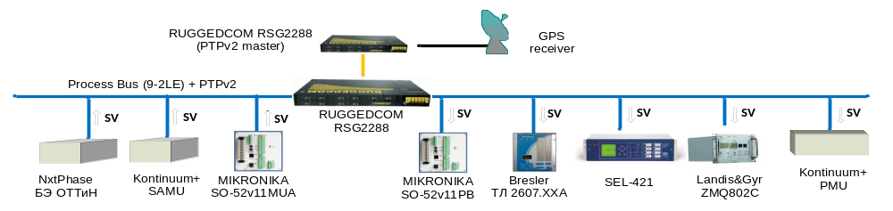

Fig.5. Structural scheme of testing the interoperability by the IEC 61850-9-2LE of secondary equipment of various manufacturers.
The following research was performed to evaluate the performance of the communication environment:
- Checking the network bandwidth based on unmanaged switches with 100 Mbit/s ports.
- Checking the network bandwidth based on the managed switches with 1 Gbit/s connections.
- Throughput test of PRP adapters (RedBox) 100 Mbit/s ports in the construction of the two networks on the Ruggedcom switches in the network PRP A and switches MACH 1040, MACH 1030 (Hirschmann Electronic - Germany) in the network PRP B (Fig. 6).

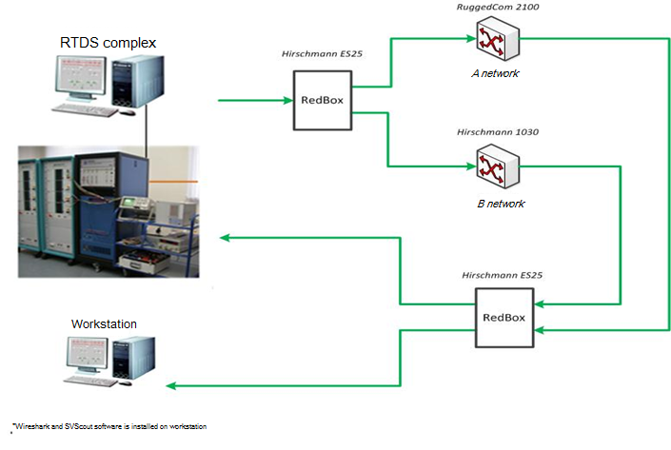
Fig. 6. Structural scheme of communication capacity of managed Ruggedcom 2100 and Hirschmann 1030 switches with 100 Mbit/s ports tests.
These results were used for development of recommendations for building architecture of “process bus” for IED terminals of the 110 kV side on the example 750 kV substation “Leningradskaya” as it is most heavily fragment of communication network in loading the information flows what is associated with the following factors:
- Most “information-loaded” VT is located on the 110 kV outdoor switchgear with number of connected IEDs up to 22 units.
- Most “information-loaded” IED terminal of differential busbar protection 7SS522 (Siemens, Germany) is located on the 110 kV outdoor switchgear which is connected to 11 CTs.
Researching led to the following conclusions:
- During the tests revealed that the amount of transmission delays of packets describes the degree of loading of the communication equipment.In this connection, when the commissioning of substation communication network latency measurement is mandatory procedure. Measuring values of time delay must be made within a sufficiently large time interval (at least 30 minutes). It is also necessary to verify the absence of packet loss in the communication environment, which can be observed in short-term failures in the equipment which do not lead to an increase in delays.
- Process bus should be based on the PRP technology of redundancy. A and B PRP bus can be based on one or more equipment manufacturers switches, thus it is necessary to use network redundancy technology RSTP and STP to restore communication (network topology change) at breakage of the link between switches or failure of the switch. IED terminals, MU must support PRP technology. In the absence of this support, you can use special PRP adapters for network RedBox .
- Currently on the market there are no devices communications equipment RedBox, supporting bandwidth information flows 1 Gbit/s. In this connection, terminals requiring more than 12 streams 80 points / cycle, and do not support PRP, must provide for the possibility of separating the reception streams in two or more (depending on the number of streams), different 100 Mbit/s ports.
- Building process bus without using VLAN leads to excessive load on the ports of all devices (ie all terminals receive all streams), which is not recommended. GOOSE messages and SV flows should not be in the same VLAN and have the same address.
- In constructing the substation communication network with a large number of connections to implement the differential busbar protection, it is recommended to build on the process bus with 1Gbit/s ports, with the possible use of different network topologies (star, ring, etc.) depending on the requirements of reliability (restoration of the A or B network is provided with RSTP protocol). Using 1 Gbit/s bus allows diagnosis of all flows of a class of stress at any point in the network. To monitor the status of the communication network should be used SNMP protocol.
- While transmitting on the same physical channel GOOSE messages and SV streams recommend to set at SV streams obviously a higher priority than the GOOSE messages to address the negative impact on the SV streams. It is recommended to use hardware that supports VLAN priority (otherwise impossible to achieve acceptable transmission delays SV streams and a large number of GOOSE messages)

Conclusions
- The development and implementation of technology "Digital Substation" should be defined priorities (R & D) set development priorities of scientific and technical documentation and other documents in different time horizons.
- When implementing a new technology the stages can be corrected, but correction mechanism must pre-set and should not only be based on market principles, but also include the components of the administrative and organizational levers.
- Integrity of technology, creation of basic preconditions for the development of new equipment industry can be achieved through public-private partnerships, but initially public investment should prevail.
- Implementation of the technology "Digital Substation" to "pilot" UNEG facilities and distribution grid complex should be linked with the results of the stages 2, 4, 5-10.

BIBLIOGRAPHY

[1] Morzhin Yuri, Popov Sergey and others. Digital substation of UNES. Energoexpert №4, 2011, www.eneryexpert.ru
[2] Morzhin Yuri, Popov Sergey, Korzhetskiy Yuri, Ilin Maxim. Stages of developing and implementation “Digital substation” technology on UNES objects. 4th International Scientific Conference "Modern Trends in Development of Power System Protection and Automation". Ekarinburg 3-7 of June 2013. Section 3.1 (report C.3.1-6)
[3] INTERNATIONAL STANDARD IEC 61850-10 Communication networks and systems in substations –Part 10: Conformance testing (First edition 2005-05)

