

21, rue d’Artois, F-75008 PARIS С2_110_2014 CIGRE 2014
http : //www.cigre.org

Stability monitoring and control of generation based on the synchronized measurements in nodes of its connection

A.G. Fishov*
M.A. Soboleva
Novosibirsk State Technical University (NSTU)

A.I. Dechterev
Sinetic CJSC

Russia

V.A. Fishov
D.V. Tutundaeva
Novosibirsk regional dispatching department
(JSC SO UPS)

SUMMARY

According to the proposed technology the generator's output power restrictions are determined in real-time by the terms a static stability using the generators' mode model as a multipole with connection nodes of generators' electromotive forces (the matrix of self and mutual admittances (SMA) of EMFs generators).The following parameters are used to identify the model: parameters of generators, results of synchronized measurements of voltage modulus and phase, active and reactive power on the generators' buses of the set of quasi-steady modes, which are discriminated during the process of redistribution power between generators (in control, regulation of the frequency and power or while the electromechanical fluctuation of rotors).
The mentioned parameters are used for the calculation of EMF vectors and generators’ internal powers for each of quasi-steady modes. The parameters of the multipole are defined by solving the overdetermined equations system, where generators’ output powers and EMF vectors for each of quasi-steady modes are known and SMA of EMFs generators are unknown. The overdetermination of the equations system is necessary for consistency of results. The obtained model is used to determine the generator's output power restrictions for quasi-steady and post emergency modes. Тhе generators’ field current restrictions and turndown of active power, as well as exciting regulator’s work can be taken into consideration.
During the operating control, while operator is controlling the stability with the suggested technology, several actions should be performed. Firstly, the operator reduces the generator’s output power for some small quantity, which is sufficient for identification of SMA matrix during the redistribution of power in the system. After the procedure of identification and definition of the generator’s output power restrictions was done, then the desired change of the generation mode can be implemented. Furthermore, during the process of changing the control of the restrictions in real time continues. If changes of the normal mode of the grid are unpredictable, the generator’s output power restrictions are defined and used if necessary for prevention of disturbance of the resistance by automatics or acting promptly.
The application of the technology would be typical for: distribution grid with the main substation and generators of the commensurable capacity which are connected in different nodes; transmission grid, which contains large power plant (generators) and distributed by the node generation. In the first case the one-level control system for all of generators of the distributed grid is implemented, where the power limits of each of the generators is defined for the direction of weighting: generator - main substation. In the second case, the two-level control system is brought in, based on the separation of motion of large and small generation.
The results of the method and technology efficiency verification are shown, both by computer simulations of the power system modes and by its physical model.

KEYWORDS

Power system- stability- synchronized measurements- normal- transient- post emergency modes

The control of the mode stability during the operation of electric power system (EPS) is essential in the systems of technological and emergency control schemes, operating control for providing stability of the parallel operation of generators either in normal, post emergency mode or in relatively short quasi steady mode, which happens after the immediate attenuation of electromechanical transients.
The currently applied methods of control are based on the usage of mathematical models of the electric transmission system, which are based on the grid topology and parameters of all its elements [1].
The integration of the distributed generation into electric transmission systems with large power plants in the area of distribution grid increases the complexity of the problem and considerably complicates a required control system. Furthermore, the efficiency of its usage decreases. This presents the technological barrier to the development of distributed generation and offers an opportunity for new technology to control the stability, which would enable more preferable conditions for integration of distributed generation in the current EPS and grid.
Synchronized distributed measurements of modes` parameters create a technical feasibility for development and implementing new technologies of control the mode stability and the acceptability of EPS mode which are able to solve the problem. These measurements enable to obtain models for taking into consideration limits towards stability of EPS mode to the operating and automatic emergency control which suit current mode of the grid but without them being totally controlled. Such feasibility are explored in some works [2-4] as well as in the current work [5-7].
- THEORETICAL BASIS
  - Model of generators mode and control of some grid parameters
The proposed technology of controlling the limits for generators to distribute the capacity by the condition of a static stability in real time is based on the model of mode of generators in terms of multi-port circuit nodes of connection of their electromotive forces (the matrix of SMA of generator EMFs.). In initial condition model does not contain another nodes of commonly used equivalent circuit of EPS besides nodes of generator EMF. This means that loads of the systems are shown as linear bridges. Counting or miscounting voltage regulation depends on equivalent circuit being used and the way of describing changes of the EMFs.
Let`s show electrical mode of EPS generators in the current time period as passive linear multi-port with EMF connected to the nodes.
Mode of n generators is describes by system of equations:
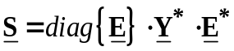 , (1)
where - matrix (vector ) of inside active and reactive powers of generators on the nodes of EMF.
- square matrix of self- and mutual admittances (SMA) of generator EMFs.
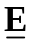 - matrix of vectors of generators EMFs.
Mode of each of generators is described as:
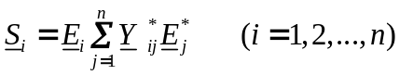, (2)
where i and j – index which shows number of generators in the scheme.
– inside power of i generator.
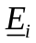,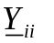and 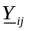 - elements of matrix and .
Equation (2) can be written as:
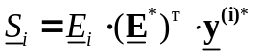 (3)
where 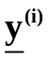 – column matrix (vector) SMA of i generator which conforms to i line of matrix.
Synchronized measurements of active and reactive power, vector measurements of voltage in the nodes of power connection allow for each of the time periods (power modes) calculate matrix and .
Rewrite equation (3) for n-1 generator for one mode and we have more generally undefined system of linear independent equations relatively to SMA vector of generators, unit vector:
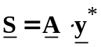, (4)

where 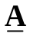 - right-angled matrix, which coefficients are product EMF with index coincide with index of conductivity, though in every line element with distinct first index of the line are cleared.
For making system of equations (4) defined (with square matrix) or redefined it should be complimented using measurements for different time periods of transitional mode together with redistribution power between generators.
In the result of solving defined or redefined system of equation (4) there are parameters of multi-port (SMA of generator EMFs.)
With necessity of control inside parameters of the grid (voltage in some nodes, power flow in the dedicated section) it should be extra synchronized measuring instrument in the appropriate nodes of the grid and power lines. By the results of measurement, identification of complex coupling coefficients with EMF of generators and then defining needed controlled parameters in quasi steady and post emergency modes are possible.
  - Model identification

The necessary condition for actual SMA matrix identification (having system of equation (4) without degeneracy) is occurrence of steady state changes (redistribution of power between generators). It is possible by 2 ways:
- The first is by using sporadic disturbance of normal mode of EPS in the result of emergency disturbance. In this case SMA matrix identifies in the time period of transient mode which is connected with attenuation of electromechanical transients and the application domain is control of acceptability quasi steady and steady post emergency mode (PEM).
- The second is by using artificial changes of mode, e.g. by using short time unloading of generator by active power. In that case there can be provided the control of limits of acceptability of normal mode (limits of producing power by generators).
The sufficient condition of actual SMA matrix identification is a representation of generators that characterized by in-phase rotors motion as the one equivalent generator, so far as in general case in complicated multi-machine EPS a power redistribution between generators (or power plants) during disturbances or operations occurs between some of generators only. An absence of mode changes of residual generators does not allow identifying their mutual admittances due to a degeneracy of the system of equations. The obtained model in this case shows the structure of the mutual generators motion during the power redistribution between them.
The overdetermination of the equations system (4) is required for stable results under a presence of the measuring error and method error conditioned by the substitution of a real object mode by its specified model. In the Figure 1 the mutual admittances identification results for the scheme “three generators - infinite buses” are presented. One can see from the Figure 1 the measurements redundancy increase improves the stability of identification results of SMA matrix values.
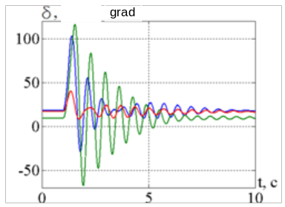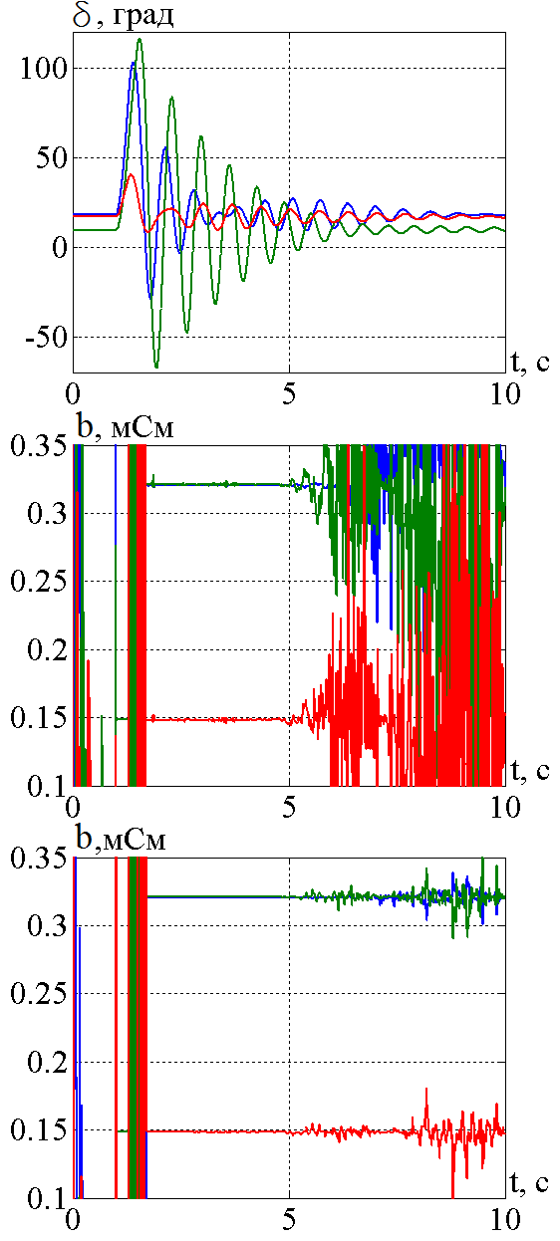

а) b) с)

Fig. 1: The impact of the redefining ratio of the set of equations on the stability of identification results of the SMA matrix during electromechanical transients after stable state disturbance (identification “window” is 3-5 sec.):

(а) – oscillations of generators rotor angels; (b) – one of the SMA matrix conductivities subject to the fourfold redefining of the set of equations, (с) – one of the SMA matrix conductivities subject to the tenfold redefining of the set of equations.
  - Using the model for control
The model obtained can be used in calculating the limits on the power output of each network generators for the steady state, quasi-steady-, and post emergency mode taking into account the work of excitation regulators.
During the operating control of the output power of the generators, while operator is controlling the stability with the suggested technology, several actions should be performed. Firstly the operator reduces the generator’s output power by some small quantity, which is sufficient for identification of SMA matrix during the redistribution of power in the system. After the procedure of identification and definition of the generator’s output power restrictions were done, then the desired change of the generation mode can be realized. Furthermore, during the process of changing the control of the restrictions in real time continues.
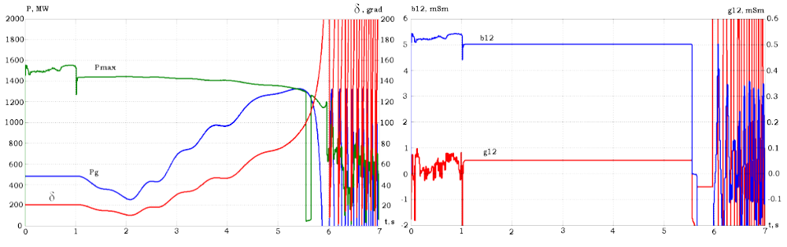
а) b)
Fig.2. Generator power control with process monitoring restrictions on the power output, bringing to an intentional violation of the stability limit
a) The operator observed parameters; b) identified conductivity (window 1-5.5 s)
If unexpected changes occur in normal network conditions, also the power output limits are defined to be used if necessary to prevent violations of stability automatically or manual. In particular, applied to the control power of the turbine condition provide the required reserve of static stability in steady post emergency mode can be adjusted level of continuous unloading of the turbine. This will improve the controllability of EPS and reduce redundancy control actions.
The structure of restrictions control system for different purposes networks has the features.
a. Distribution network with supply center (node connection to the main network) and generators in different nodes. In this case, a single-level control system is implemented for all generators of the distribution network. Limit power of each generator are determined to direction of weighting generator - supply center.
b. Transmission network EPS containing large power stations (generators) and on small nodes distributed generation. In this case, two-level control system is implemented on the basis of separation of motions large and small generation. Parallel work stability of large generators is provided by traditional technology. Stability areas with distributed generation - according to the proposed technology under controlled conditions movement of large generators.
  - Advantages and peculiarities of the method

The proposed method assumes the stability control in node coordinates (generators active power coordinates), that provides follow advantages:
- The absence of a necessity of total equipping of EPS by measuring means. It is enough to install recorders at the power plants buses only.
- Network structure independence, as far as an association with specified network sections is not required.
- Informativity, because the structure of the identified SMA matrix shows the structure of the generators rotor motion including information about an existence of in-phase moving generator groups which stability is under the threat in current network conditions. It allows choosing the vector of regime loading appropriated for current conditions when post emergency stability limits are calculated.
- Universality, because stability margin control is possible as for a transmission grid so for electrical networks with distributed generation.
- Availability in the turbine power control loop.
2. THE RESULT OF METHOD AND TECHNOLOGY EFFICIENCY VERIFICATION
  - Verification via simulation modeling
Comparative calculations using the software and computing system (SCS) "Mustang" held for Surgut EPS of UEPS of Russia, a complete circuit is shown in Figure 3, and the equivalent (based on an actual matrix SMA EMF equivalent generators) - Figures 4a, 4b.
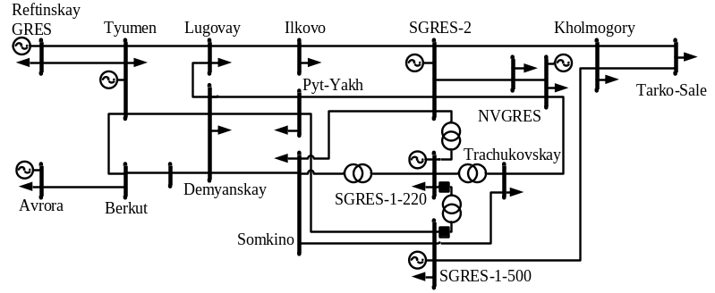
Fig. 3 – Scheme of the Surgut EPS
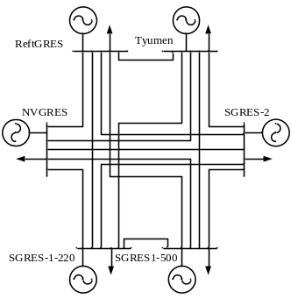 | 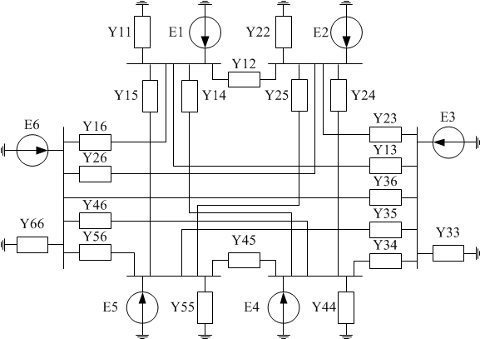
a) | b)
Fig. 4 - Surgut EPS
(a) - an equivalent circuit diagram; (b) - the equivalent computational scheme
Parameters of the initial mode of the relevant matrix SMA EMF generators used for subsequent weighting shown in Table 1.
Table 1 - Parameters of the initial regime for weighting based on the relevant matrix SMA EMF generators
№ node | Name | Pg, MW | Eg, kV | Qg, MVAr | δ, rad
1 | ReftGRES | 703,4 | 522,0 | 527,6 | 0,0000
2 | Tyumen | 1 203,0 | 556,1 | 262,2 | 0,2067
3 | SGRES-2 | 4 800,0 | 546,7 | 1 428,8 | 0,4947
4 | SGRES-1-220 | 1 165,0 | 583,3 | 791,9 | 0,1114
5 | NVGRES | 865,0 | 583,5 | 523,5 | 0,3980
6 | SGRES-1-500 | 2 008 | 545,4 | 593,4 | 0,4185
Matrix SMA identified on the calculation of the transient process after a disturbance EPS mode. In the calculations with weighting for the base node receives Reftinskaya GRES and consistently weigh down each of the five nodes of the circuit.
Results of calculations limiting on the stability condition active power generating units from the matrix SMA EMF equivalent generators and complete calculations the equivalent circuit model of the Surgut power unit controlled EPS are shown in Table. 2.
Table 2 - Estimated limiting active power generating units
Power system model (including AER) |  | Name nodes weighting | Limit active power generating units Pmax, MW |  | Disagreement regarding the complete digital model EPS, %
 |  | Name nodes weighting | Complete digital model of EPS | Matrix SMA EMF generators | Disagreement regarding the complete digital model EPS, %
Model generator voltage regulation | E=var, U_{г}=const | Tyumen | 8 856,3 | 8 937,4 | 0,92
Model generator voltage regulation | E=var, U_{г}=const | SGRES-2 | 7 207,5 | 7 208,8 | 0,02
Model generator voltage regulation | E=var, U_{г}=const | SGRES-1-220 | 3 633,9 | 3 598,5 | 0,97
Model generator voltage regulation | E=var, U_{г}=const | NVGRES | 3 269,0 | 3 266,9 | 0,06
Model generator voltage regulation | E=var, U_{г}=const | SGRES-1-500 | 4 411,0 | 4 413,5 | 0,06
Model generator voltage regulation | E=var, U_{г}=const while Q_{г}<Q_{max} | Tyumen | 5 326,6 | 5 357,0 | 0,57
Model generator voltage regulation | E=var, U_{г}=const while Q_{г}<Q_{max} | SGRES-2 | 6 378,7 | 6 327,5 | 0,80
Model generator voltage regulation | E=var, U_{г}=const while Q_{г}<Q_{max} | SGRES-1-220 | 2 753,1 | 2 780,3 | 0,99
Model generator voltage regulation | E=var, U_{г}=const while Q_{г}<Q_{max} | NVGRES | 2 437,3 | 2 409,0 | 1,16
Model generator voltage regulation | E=var, U_{г}=const while Q_{г}<Q_{max} | SGRES-1-500 | 3 588,0 | 3 588,8 | 0,02

It should be noted that in the general case, the calculation error limit active power generating units from the matrix SMA EMF defined: measurement errors regime parameters, structure and amplitudes mutual motion generator rotor on the interval (window) identification matrix SMA, linearity load model, replacement of group generators with in phase moving rotors in the transition process to one equivalent generator, composition accounted regime restrictions, as well as the reliability of the convergence process solutions of the equations of the steady state in weighting procedures.
  - Verification via physical models
The proposed method was estimated in conditions approximated to actual operating conditions using the NIIPT digital – analog – physical simulator (electro-dynamic simulator – EDS) and the NSTU EDS. Verification of physical and mathematical models (created in the Mustang Software) were performed by comparison of process oscillograms.
2.2.1. Schemes for the testing
Schemes of test power systems are presented in the Figure 5.
а) 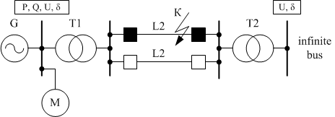 b)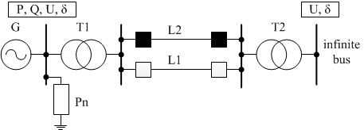
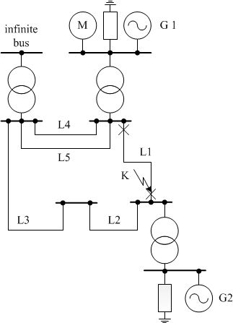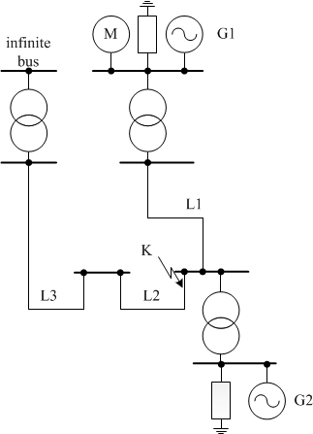
c) d)
Fig.5: Schemes of physical models of test power systems
a,b – schemes at the test center of NSTU that differ by a type of a loading connected to generator buses;
с,d - schemes at the test center of NIIPT with radial and ring topologies.
2.2.2. Testing at the test center of NSTU
In schemes (Fig.5 a, b) for a recording of operation parameters the BEN 5000 Digital Fault Recorder with a GPS receiver as the Phasor Measurement Unit (PMU) was utilized. Measurements of instantaneous voltages and currents values were performed with a rate of 2400 samples per second. By using received instantaneous values of voltages and currents effective values and phases of currents and voltages of the first harmonic for the positive-sequence were estimated. The phase of the current was estimated relative to the appropriate generator voltage and the phase of the generator voltage – relative to the infinite buses voltage. By using measuring values of the current and the voltage of the generator the active power, the reactive power, effective values of the voltage and the mutual phase with the period of 20 ms were estimated.
The oscillogram represented changes of operation parameters of the generator during the transient process is shown in the Figure 6a. The screenshot is made in the viewer of BEN 5000 records.
The oscillogram represented changes of the active power and the estimation of the output power limit of the generator during the transient process is presented in the Figure 6b.

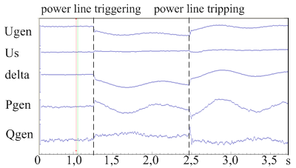
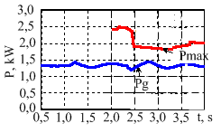

a) b)
Fig. 6: Changes of operation parameters of the generator (a), the current active power (P) and the estimation of the output active power limit (P_{max}) of the generator (b)
Summarized assessments of the output active power limit that were obtained by means of a weighting method and by means of the SMA matrix are presented in the Table 3.
Table 3 – Generator output active power limits (the scheme is presented in the Fig. 5а)
Scheme | The generator active power limit (P_{max}), kW
Scheme | By means of the weighting method | By means of the SMA matrix
Two lines are switched on | 2,8 | 2,8
One line is switched on | 1,7 | 1,8
2.2.3. Testing at the test center of NIIPT
Measurements of operation parameters were performed by means of the fault recording system developed at the test center of NIIPT. The recording of instantaneous voltages and currents values were performed with the rate of 2400 samples per second. By using measured values of the current and the voltage of a generator the active power, the reactive power, effective values of the voltage and the mutual phase were estimated with the period of 30 ms.
In the Figure 7 for the scheme presented in the Figure 5b in the condition of a tripped two-phase fault at the sending end of the line L2 changes of the active power of the generator during the transient process (P) and the real time estimation of the output power limit of a generator by the terms of static stability by using the SMA matrix are presented.
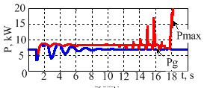
Fig. 7: The current active power (P) and the output active power limit (P_{max}) of the generator (the simulation modeling, the window of the identification of the SMA is 2-12 s)
In the Figure 8a changes of operation parameters of a generator during the electromechanical process obtained by using the physical model are shown. In the Figure 8b a real time estimation of the output power limit of a generator by means of the SMA matrix is presented.
a) 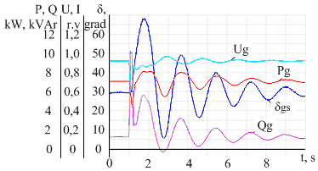 b) 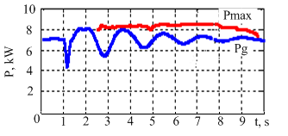
Fig.8: Oscillograms and an estimation of the output power limit obtained by using a physical model
a - changes of operation parameters of generator in the condition of a tripped two-phase fault at the sending end of the line L2;
b - the current active power (P) and a real time estimation of the output power limit of the generator (P_{max}), a window of the SMA identification is 2-8 s.
The output active power limit that were obtained by means of a weighting method and by means of a matrix of the SMA using of a physical model are 8,0 and 8,2 kW.
Summarized assessments of the output active power limit that were obtained by means of a weighting method and by means of the SMA matrix in conditions of changes of operation parameters using physical models (for schemes with two generators) are presented in the Figure 9 and Table 4.
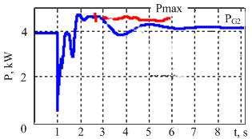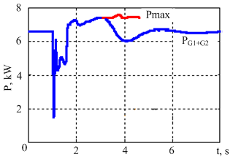
a) b)
Fig.9: Assessments of output power limits using a physical model
a - the output power limit of the generator G2 (Fig. 5c), a window of the SMA identification is 2,5-5,5 s
b - the output power limit of an equivalent of the in-phase group of generators that consists of generators G1 and G2 (Fig. 5d), a window of the SMA identification is 2,5-4,5 s.
Table 4 Output power limits of the generator G2 (Fig. 5c) and the equivalent of the in-phase group of generators that consists of generators G1 and G2 (Fig. 5d)
Scheme | The power limit (P_{max}), kW
Scheme | By means of the weighting method | By means of the SMA matrix
Figure 5с | 4,70 | 4,57
Figure 5d | 7,45 | 7,40
Results obtained by using physical models in conditions approximated to actual operating conditions confirm a validity of abstract theorems that are presented in the first section.
CONCLUSIONS
- It is possible to identify an actual matrix of the self and mutual admittances (SMA) of generator EMFs by using the synchronized (phasor) measurements at generator buses and to get a real time assessment of limit conditions of a power system by the terms of a static stability via matrix of the SMA.
- It is advisable to perform a real time monitoring of static stability limits in a post-emergence mode of a power system in two stages. The first stage is a short-term quasi steady mode that comes immediately after the electromechanical transient attenuation. The second stage is long term post-emergency state. It is useful to get static stability limits at each stage and then use those assessments in the emergency automation.
Bibliography
[1] B.I. Ayuyev, V.V. Davydov, P.I. Erokhin Optimization Model of Limiting Operating Modes of
Electric Systems. – Electricity, 2010, №11, P 2-12.
[2] B. Mohammadi-Ivatloo, M. Shiroei, M. Parniani Online small signal stability analysis of multi-machine systems based on synchronized phasor measurements / Electric Power Systems Research 81 (2011) 1887– 1896.
[3] A Measurement-based Framework for Dynamic Equivalencing of Large Power Systems using WAMS Aranya Chakrabortty1, Joe H. Chow2, Armando Salazar3 1 Electrical & Computer Engineering Department, Texas Tech University, Lubbock, TX. 2 Electrical, Computer and Systems Engineering Department, Rensselaer Polytechnic Institute, Troy, NY. 3 Southern California Edison, Rosemead, CA/978-1-4244-6266-7/10/$26.00 ©2010 IEEE.
[4] P.V. Chusovitin, A.V. Pazderin Monitoring of Power System Stability Based on a Dynamic
Equivalent Determined from Vector Measurements. Electricity, 2013. № 2, P 2-10.
[5] D.V. Toutoundaeva , A. G. Fishov Improvement of the Power System Stability Margin Control
and Standardization Technique. Scientific Herald of Novosibirsk State Technical University,–
2011. – №2(43). – P. 147-160. – ISSN 1814-1196.
[6] M.A. Soboleva, A.G. Fishov Determining the Limiting Electric Power System Operating
Conditions on the Basis Admittances Matrices with Respect to the EMFs of Equivalent
Generators. Electricity. 2013. № 8. P. 9-14.
[7] A.G. Fishov Patent of the Russian Federation № 2500061 Way of stock control the stability of the mode of synchronous electric machines included in the electricity network. Bulletin of inventions № 33, 27.11.2013

